**SCENE IMAGES**

**Initial Screen**

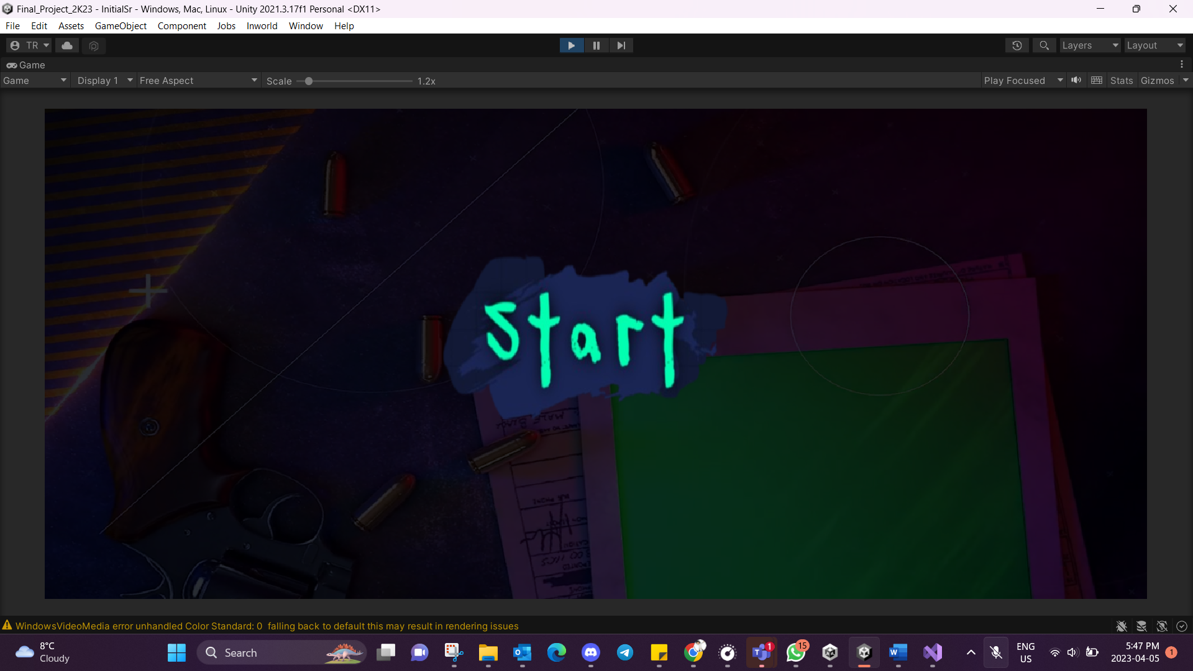

**Menu Screen**

**Heist Scene**

**